Instructions Revision for Dishwasher Connector
COMM – 1009 - NET - Technical Writing - 70660
R Rashid
March 29, 2023

GENERAL ELECTRIC UNIVERSAL 6’ DISHWASHER CONNECTOR

WATER CONNECTOR INSTALLATION INSTRUCTIONS
These instructions are for installing a universal dishwasher connector from a dishwasher unit to a water supply connection. The connector fits most leading brands of dishwashers. No special plumbing or electrical skills are required to complete this project.

READ ALL INSTRUCTIONS CAREFULLY BEFORE INSTALLING
- FOR USE ON HOT AND COLD WATER APPLICATIONS
- To be used with pipe thread or compression valve outlets.
- No cutting, bending, or flaring required.
- Operating temperature 40 – 140 ⁰C with intermittent temperatures up to 180 ⁰C
- Maximum operation pressure of 125 psi.
- Before beginning the installation, identify the water supply connection. Attaching this connector to the wrong water supply connection may result in leaks.

Tools and Materials Needed for Installation:
- Adjustable Wrench
- Protective cloth
- Teflon thread tape

WARNING: Do not use for gas supply connections. The connector is only to be used with water in readily accessible locations.

INSTALLATION TO DISHWASHER
- Shut off the water supply to the valve.
- Install 90⁰ elbow (Figure 1):
- If using brass pipe elbow (Figure A), apply Teflon thread tape or other thread sealant to large end of brass pipe elbow and thread into dishwasher inlet. Hand tighten, then wrench tighten 1/4 turn more.
- If using garden hose elbow (Figure B), thread 3/4-inch end of garden hose elbow into dishwasher inlet. Hand tighten, then wrench tighten 1/4 turn more.
Note: DO NOT OVERTIGHTEN. Overtightening may cause leaks. To avoid overtightening, always hand tighten first then wrench tighten 1/4 turn more.
- Thread one end of the dishwasher connector (Figure C) to 3/8-inch end of elbow. Hand tighten, then wrench tighten 1/4 turn more.

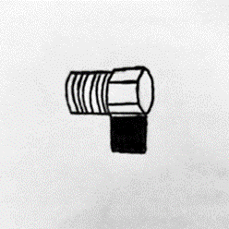  Figure A: 3/8-inch Brass Pipe 90⁰ Elbow | 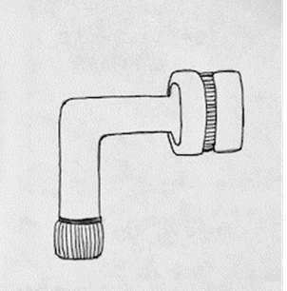  Figure B: 3/8-inch Compression x 3/4-inch Garden Hose 90⁰ Elbow | 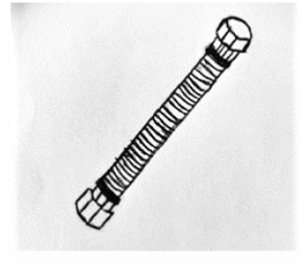  Figure C: Six Foot Dishwasher Connector

INSTALLATION TO WATER SUPPLY VALVE OUTLET
- Determine the size of the outlet valve.
- If outlet is 3/8-inch compression, thread the dishwasher connector directly onto the valve outlet (Figure 1). Hand tighten, then wrench tighten 1/4 turn more. Proceed to Step 6.
- If outlet is 1/2-inch compression valve adapter (Figure D), place a flat washer into the compression adapter and thread onto valve outlet. Hand tighten, then wrench tighten 1/4 turn more. Use a cloth on nut to protect the finish. Proceed to Step 5.
- If outlet is 1/2-inch pipe thread valve adapter (Figure E), place a cone washer into pipe thread adapter and thread onto valve outlet. Hand tighten, then wrench tighten 1/4 turn more. Use a cloth on nut to protect the finish. Proceed to Step 5.

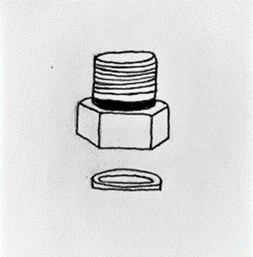  Figure D: 1/2-inch Compression  Valve Adapter with Flat Washer | 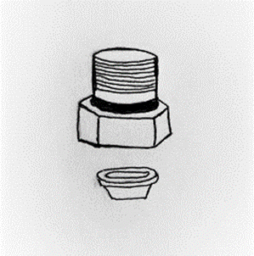  Figure E: 1/2-inch Pipe Thread Valve Adapter with Cone Washer

- Thread the new dishwasher connector onto the adapter (Figure 2 for 4b and Figure 3 for 4c). Hand tighten, then wrench tighten 1/4 turn more.
- Turn on the water supply and check for leaks. If any leaks appear, carefully tighten nuts 1/8 to 1/4 turn more until the leak stops.

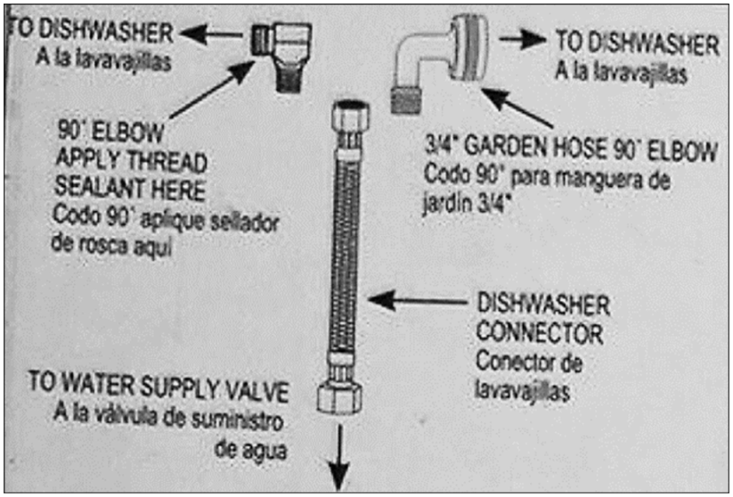  Figure 1: Connection to Dishwasher with 3/8-inch Compression x 3/4-inch Garden Hose 90⁰ Elbow | 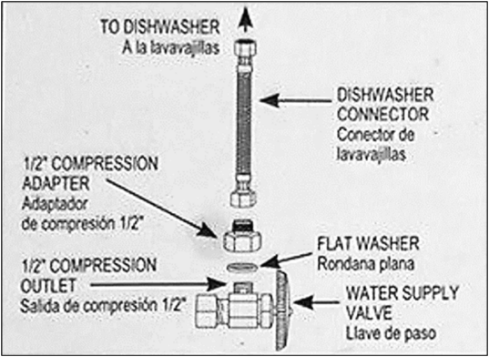  Figure 2: Connection to Dishwasher with 1/2-inch Compression Valve Adapter with Flat Washer | 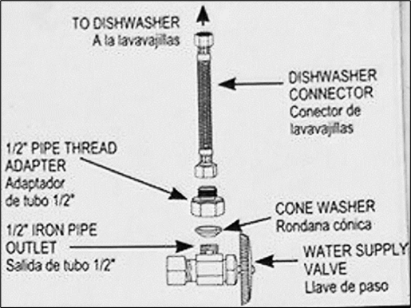  Figure 3: Connection to Dishwasher with 1/2-inch Pipe  Thread Valve Adapter with Cone Washer

Sources:
- Bad Installation Instructions on Home Depot’s Universal Dishwater Connections. (2006). Retrieved March 8, 2023, from: https://www.arencambre.com/2006/12/02/bad-installation-instructions-on-home-depots-universal-dishwasher-connection/
- The Home Depot. 6 Feet Universal Dishwasher Kit. Retrieved March 18, 2023,from: https://www.homedepot.com/p/GE-6-ft-Universal-Dishwasher-Kit-PM28X326/203781301#overlay
- eBay. GE General Electric PM28X326 Universal Dishwasher Water Connection Kit, 6-Foot. Retrieved March 18, 2023, from: https://www.ebay.com/itm/195504078910
- Image retrieved from: https://www.ebay.com/itm/195504078910
- Reference for drawings: https://www.homedepot.com/p/GE-6-ft-Universal-Dishwasher-Kit-PM28X326/203781301#overlay

