Web Content Project
Constructing Content for An Education Website for Home Schooling and Supplemental Learning
XCOMM - 1110 - Writing for the Web
British Columbia Institute of Technology
R Rashid
December 2, 2022

Audience: Parents seeking information and curriculum for home schooling
Persona Name: Ms. Potter
Persona Description:
Ms. Potter is a 29-year-old mom, who currently works at home as a part-time bookkeeper. Her husband, Harry, works full-time as a chemistry professor. They have an eight-year-old daughter, Lily, who will be starting grade three in the upcoming school year. They have opted to home school her next year because they both feel that an at home education would be more beneficial to their child than the public-school system. Ms. Potter will be the primary provider of this education because she works 15 to 20 hours per week and has more flexibility in her schedule to instruct their daughter. However, her husband has a science background so he will be assisting with the home schooling in this subject. Lily enjoys school and loves to read and learn, but she is a little behind in her reading skills according to grade level and struggles with math. Her class size this year is large and the ratio of teachers and education assistants to students does not favor the one-on-one attention that she needs to bridge the gaps in her learning.
Ms. Potter has begun to do research on home schooling and has joined a parent’s online Facebook group for home schoolers. However, she still needs resources and guidance on an elementary school curriculum. She wants to make sure that the resource she uses would meet national standards in education. She is also unsure of how to teach her child effectively, so that she will be able to do well in grade three. She is looking for a comprehensive curriculum for her child to complete on a schedule. She is also seeking guidance on how to start teaching and what subjects she needs to focus on at the grade three level.
Persona Questions/Needs/Tasks:
- How do I transition from public school to home schooling?
- Where can I find curriculum that meets national standards in education?
- Where do I find teaching materials, curriculum books and exercise books?
- Where should learning take place?
- How many hours per day should home schooling last?
- What subjects are taught in elementary school?
- Where can I find curriculum that is specific for grade three?
- How do I evaluate my child’s progress so that I know she is learning?
- How do I keep track of her progress?
- Do I need to assign grades for my child or make a report card?
ABC Home Schooling
Home Grade K to 5 Grade 6 to 8 Grade 9 to 12 Blog Shop About Us Contact Resources
We Help You Educate!
Welcome to ABC Home Schooling! We provide curriculum for kindergarten to grade 12 students to help guide your family on home schooling. Whether you want to home school your child or supplement their learning, we are here to help!
Our free curriculum meets national standards in education. All our lesson plans were developed by teachers so you can be sure that we provide a quality education to help your child succeed. We provide all the resources you need to start with home learning.
We also have an informative blog to answer frequently asked questions that parents may have about learning at home. We will guide you through the home schooling process, so you will be ready to teach, and your child will be ready to learn!
Choose your Grade Level
Elementary (k – grade 5)

Middle School (grade 6 – 8)

High School (grade 9 – 12)

ABC Home Schooling
Home Grade K to 5 Grade 6 to 8 Grade 9 to 12 Blog Shop About Us Contact Resources
Our Home School Blog
Home Schooling 101
Getting Started
If you are not sure where to begin with home schooling, then we are here to help! Getting started is easier than you think!
We have curriculum for elementary, middle, and high school students at every grade level. All our subjects are available as video lessons to supplement your teaching. We provide worksheets and practice tests that you can download for your child to complete. We also have interactive quizzes and games to help engage your child in learning. You may access our sample lesson plans and teaching tutorials on our resources page to help you start your home schooling journey.
Our curriculum was developed by teachers based on guidelines from the department of education, so you can be confident that you can help your child meet their education goals. Here are the core subject areas taught at each school level:
Subjects by School Level
Elementary School  (K – Grade 5) | Middle School  (Grade 6-8) | High School  (Grade 9-12)
Science  Math  Language Arts  Social Studies | Science  Math  English  Social Studies | Math  Chemistry  Physics  Biology  English

Each of our subject categories have grade specific lessons and practice tests to ensure that your child gets a complete education.
How to Set Up a Home Classroom
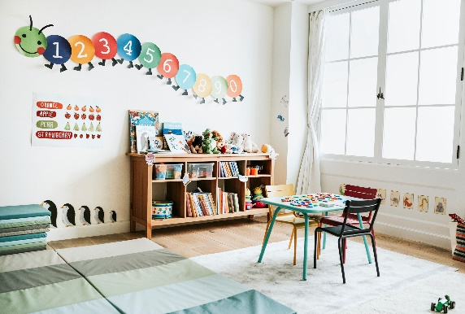
It is important to set up a learning environment at home. Having your own at home classroom will help your child stay focused on completing their learning activities.
This area should be separate from play areas and other busy areas where there are too many distractions. If you have a spare room, then this would be ideal for a home classroom. Otherwise, a learning space in a child’s room or in a family room works well too.
Organize everything you need for day-to-day teaching and learning in this space. Set up a bookshelf, a desk, organize school and art supplies, put up a wall chalkboard, and a clock, or anything else that would give this space the look and feel of a classroom.
Make home schooling fun by having your child create their own artwork to decorate the school room walls. Hang a bulletin board or wall chart for stickers or stars to mark achievements and reinforce positive learning. There are so many ideas online for home classrooms. Do your research and make the space your own!
Creating a Daily Lesson Plan
Home schooled children have the advantage of one-on-one teaching and learning that meets their needs. An average school day is eight hours, but there is recess, lunch break and other activities that lengthen the learning period.
The good news is that you can cover daily lessons in as little as two hours for elementary or middle school. Your child can spend another half hour to an hour doing learning activities, such as practice tests and reading. A high school curriculum may require two to three hours per day, because there are more subjects to study. Our many practice tests and interactive learning activities help students master subjects more quickly.
You can spend more time on the subject areas that your child struggles with to make sure they understand what they are learning. If you do not cover your entire lesson in one day, then you can add this to your future lesson plans. This will help you cover all the material for the school year so that your child meets the learning goals for their grade level. If your child is between grade levels, then you can bridge your child’s learning by reviewing subjects from their previous grade level.
Decide which subjects to cover and what your daily, or weekly learning goals are. Plan the daily lessons for the week and keep this organized in a teaching portfolio. You do not need to do lessons in every subject every day. For elementary or middle school students, you may choose to focus on math and science one day and reading and social studies on a different day. For high school students learning times may vary depending on the subject, and your teen may want to contribute to their learning plan. Our guided lesson plans will help you create your own daily and weekly schedule no matter what your child’s grade level is.
Remember to include breaks in the schedule. You may choose to have a 10-minute fitness break or snack break to help you and your child refocus. Taking short breaks is a great way for your child to renew themselves before moving on to the next lesson. You can schedule these breaks in your lesson plan after each lesson or take a break in the middle of the lesson. Do whatever works best for you and your child!
Keeping Track of School Progress
It is important to keep records of your child’s progress. Keep a learning journal where you record test scores and keep notes on what your child does well in, and what they need to improve on.
Keep all your child’s completed schoolwork in a learning portfolio. You may also create a report card to record your child’s grades every few months. Visit our resources page for a sample report card that you can download so you can keep a record of your child’s grade level achievements. The learning portfolio will help when your child transitions to their next grade level. It will be a useful guide and review of what your child has learned, and how they performed.
The learning portfolio and report card are also important if you want your child to return to the school system, and if your child needs to do an assessment test to determine their grade level to re-enter the school system. The assessment test would be based on what your child has learned, and how they performed according to expectations for their grade. The learning portfolio may be used to prepare for this assessment.
Plan a Field Trip
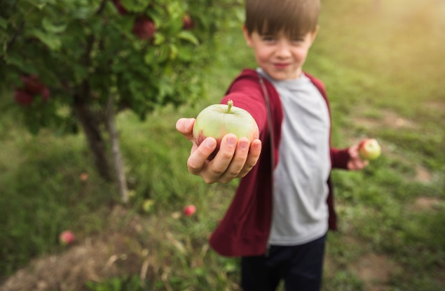
Plan learning activities around a field trip to make learning fun! Field trips are a great way to incorporate learning and supplement at home lessons.
You may want to go to the zoo for a science lesson. This is a great opportunity to teach about the animal kingdom, and how living things interact with their environment. Your child can learn about the different classes of the animal kingdom from reptiles to mammals, and all about the food chain. There are so many things your child can learn during a trip to the zoo!
You can do your lessons during a trip to the library. Have your child pick out non-fiction books on their favorite subjects or anything they are curious about, or fiction books for their daily reading practice. Have your child discuss the book they are reading by having them explain what it is about, what roles each of the characters play, and the theme. This is a great way to improve reading comprehension!
Go apple picking, vegetable picking, or visit a pumpkin patch and help your child learn about how plants and trees grow and produce food. What a great opportunity to teach your child about photosynthesis!
There are so many options for field trips. Try to plan regular educational field trips to encourage more interactive learning. This will help to engage your child and provide a well-rounded learning experience.

ABC Home Schooling
Home Grade K to 5 Grade 6 to 8 Grade 9 to 12 Blog Shop About Us Contact Resources
Elementary School (k – grade 5)
Grade k – 5
- Math
- Language arts
- Science
- Social studies

Topics Covered in Grade 3 by Subject:
Math
- Number sense with skip counting
- Comparing numbers
- Place values
- Addition
- Subtraction
- Understanding multiplication
- Understanding division
- Patterns
- Money
- Rounding
- Decimals

Language Arts
- Reading foundations
- Reading strategies
- Story elements
- Writing strategies
- Vocabulary
- Compound words
- Synonyms and antonyms
- Grammar

Science
- Living things
- Ecosystems
- Weather
- Earth science
- Forces and motion
- Electricity and magnets

Social Studies
- Citizenship and governance
- Culture and diversity
- Individuals, society, and economics
- People, place, and environment
- Interdependence
- Time and change

The above curriculum is based on the department of education’s guidelines. Our lesson plans for grade three teach all the above topics in each subject for a complete curriculum. Please visit the subject links to see details on each topic and their lesson plans. We also provide you with worksheets for each topic so your child can practice their learning and master the concepts.
Choose your Grade Level
Elementary (k – grade 5)

Middle School (grade 6 – 8)

High School (grade 9 – 12)

ABC Home Schooling
Home Grade K to 5 Grade 6 to 8 Grade 9 to 12 Blog Shop About Us Contact Resources
The Education Shop
Welcome to our education shop! Where you can find everything for your child’s learning needs. We also have resources and books to help teachers and parents.
What do you need?
- school supplies
- practice tests
- curriculum books
- leveled readers
- educational games
Books
Educational Games
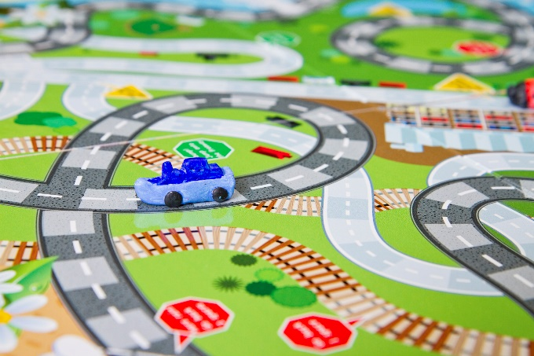
School Supplies

The Client Brief
The client, Ms. Potter, wants to know how to transition her child from the public school system to a home schooling program. She is unsure where to begin and needs reassurance to alleviate her concerns. The tone of my content is reassuring, encouraging, and helpful so that the client feels at ease and understands that this transition is not difficult with the right guidance. The website provides her with the right information for her to start her preparations for a home learning program. I chose images that I felt are visually appealing, calming and would engage the client and motivate her to read further.
The home page is welcoming and explains what the website has to offer. At the top of the home page is the company logo for ABC Home Schooling, so that Ms. Potter is aware of the brand. There is a menu bar with links for the different web pages the site has to offer at the top of every webpage, so the client is aware of exactly where to navigate to find the information she needs. All the keyword links are underlined, bolded, and are a different font colour than the rest of the text, so they are clearly visible to Ms. Potter if she wishes to navigate to the pages directly as she reads the content. I also included a menu at the bottom of the home page to choose a grade level so the client may navigate to elementary (k – grade 5), and then to grade three after reading the brief introduction.
I chose to include the blog page with short articles in a section called Home Schooling 101, because my client is new to home schooling and has basic questions on home learning, and where to get materials to effectively teach her child. For this reason, I included blog posts on how to set up an at home classroom area, how to create a daily lesson plan, how to keep track of learning goals and achievements, and how to incorporate field trips for learning. This provides the client with the background information she needs to motivate her to start researching, planning, and implementing what she learns.
Ms. Potter is also unsure about which subjects, and topics are taught at the grade three level, so I included the grade k -5 webpage link to the grade three curriculum that outlines every topic covered in each subject area. The content provides the client with the reassurance that all the curriculum and topics are based on the department of education’s guidelines, so that her child will receive the same learning plan as her peers in the public school system. In addition to the home page, blog page, and grade 3 curriculum page, I also included the education shop webpage because the client wanted to know where she can access other learning resources

ABC Home Schooling Website Map
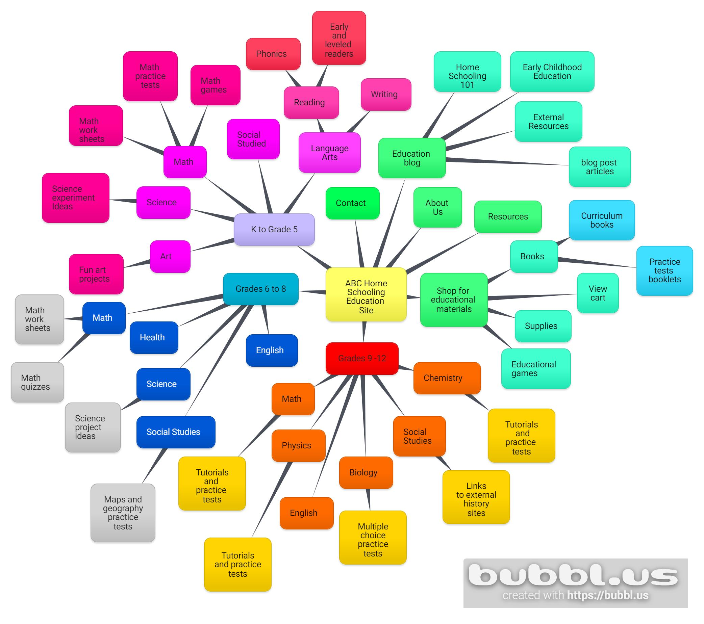

References:
- https://bubbl.us/.
- IXL Learning. (2022). Grade 3 math. Retrieved November 28, 2022, 2022, from: https://ca.ixl.com/math/grade-3
- IXL Learning. (2022). Grade 3 English language arts. Retrieved November 28, from: https://ca.ixl.com/ela/grade-3
- K5 Learning. (2021). Retrieved November 29, from: https://www.k5learninh.com/science-worksheet
- Social Studies Grade 3 Curriculum-Provincial Identity .(2011). Retrieved November 29, 2022, from: https://www2.gnb.ca/content/dam/gnb/

